# Project Summary (1 page)

This is a summary of the project, with a strict 1-page limit.

After generating PDF, strip out this page and upload it separately to FastLane.

**Intellectual Merits of the Proposal Activity**

Address these here.

**Broader Impacts of the Proposal Activity** Address these here.

# Project Description

# 1 Research Objectives

This is the first section of the 15-page technical portion of the proposal. Use citations liberally; the bibliography doesn’t count towards the page limit. State research objectives here.

## 1.1 Intellectual Merit of the Proposed Work

Describe the intellectual merit of the proposed work here.

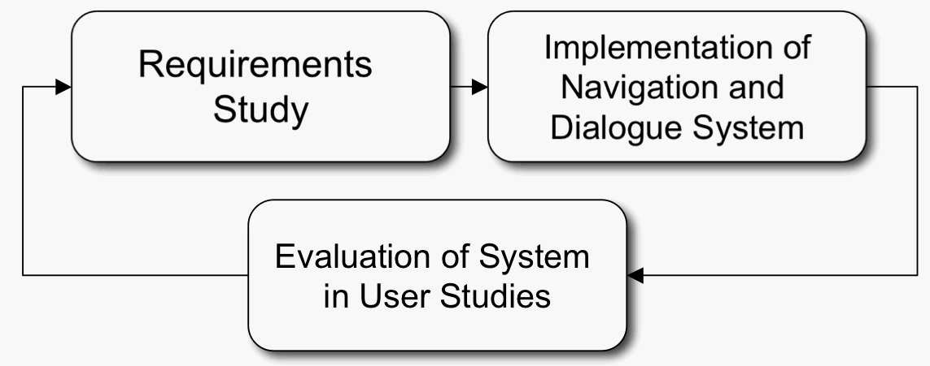

Figure 1: Our proposed research plan involves an iterated cycle of design, implementation and user testing.

Describe the intellectual merit of the proposed work here.

## 1.2 Broader Impact of Proposed Work

Describe the broader impact of the proposed work here.

Describe the broader impact of the proposed work here.

# 2 Another Technical Section

This is another technical section.

**2.1 Technical Subsection**

This is a technical subsection.

**2.2 Technical Subsection**

This is a technical subsection.

# 3 Statement of Work

Give the statement of work here. Give the statement of work here. Give the statement of work here. Give the statement of work here. Give the statement of work here. Give the statement of work here. Give the statement of work here.

1

Give the statement of work here. Give the statement of work here.

## 3.1 Schedule

|  |  |
| --- | --- |
| Year 1 | Some pieces  Some other pieces  By the end of year 1, we expect to ... |
| Year 2 | Some pieces  Some other pieces  By the end of year 2, we expect to ... |
| Year 3 | Some pieces  Some other pieces  By the end of year 3, we expect to ... |

## 3.2 Team Composition and Expertise

Our team comprises four investigators, A, B, C, and D, whose areas of expertise span the critical areas of ... A’s areas of expertise include ...

B’s areas of expertise include ...

## 3.3 Connections to Education and Outreach

Describe any connections to educational and outreach activities here. Describe any connections to educational and outreach activities here. Describe any connections to educational and outreach activities here. Describe any connections to educational and outreach activities here. Describe any connections to educational and outreach activities here. Describe any connections to educational and outreach activities here. Describe any connections to educational and outreach activities here. Describe any connections to educational and outreach activities here.

**4** **Related Work**

Describe related work [1, 2] here.

# 5 Results from Prior NSF Support

Describes any prior NSF-funded work by the PI(s) here.

Person A has served as a PI on the following NSF awards:

**NSF XXX-YYYYYYY**, TITLE

(1995–1998); PI: A This project involved ...

2

**NSF XXX-YYYYYYY**, TITLE

(1996-2001); PI’s: A, B, C This project involved ...

Person B has served as a PI or Co-I on the following NSF awards: etc.

# References Cited

[1] bar. *bar*. MIT Press, 1985. [2] foo. *foo*. MIT Press, 1985.